**Project Report Template**

**Title of Project:** KrishiBot Connect  
**Name of the Innovator:** Rajath G  
**Start Date:** 27-10-2025

**End Date:** 31-10-2025

***Day 1: Empathise & Define***

*Step 1: Understanding the Need*

* Which problem am I trying to solve?

Farmers across India face multiple challenges in accessing reliable and timely agricultural information. Most of them depend on middlemen for crop sales, receive inconsistent market rate data, and lack awareness of government schemes and modern farming techniques.  
Additionally, most digital tools are available only in English, creating a **language barrier** for rural farmers who primarily speak regional languages such as Hindi or Kannada.

* Who is affected by this problem?
* How did I find out about this? [Select whichever is applicable]
* Interviews
* Observation
* Online Research
* AI Tools

*Step 2: What is the problem?*

The problem is that **India’s farmers face fragmented access to vital agricultural information. They rely on multiple, disconnected sources for weather updates, government schemes, and market rates — often through word of mouth or unreliable mobile apps.  
Because of this, farmers frequently make uninformed crop, fertilizer, or pricing decisions, which directly impact productivity and profit.**

Why is this problem important to solve?

This problem is crucial to solve because **agriculture is the backbone of India’s economy**, and the livelihoods of millions of farmers depend on it. However, due to the **digital divide**, many farmers still lack access to accurate information, fair pricing, and modern technology.

**Take-home task**

Ask 2-3 people what they think about the project:

* **1. Farmer (Local Paddy Grower – Mr. Ramesh, Mandya District):**  
  “If KrishiBot Connect can really give advice in Kannada and tell us about fertilizer usage or rainfall chances, it will help us plan our crops better. Most of us can’t use English apps, so this kind of system will be very useful.”
* **2. Buyer (Agro Merchant – Mr. Kiran, Mysuru):**  
  “Finding genuine farmers online is difficult. A verified marketplace like KrishiBot Connect would help us connect directly with farmers and negotiate better prices without middlemen.”
* **3. Agriculture Officer (Department of Agriculture – Mrs. Lakshmi):**  
  “An integrated system that combines AI assistance, market data, and government schemes can make awareness programs more effective. Farmers often miss schemes because information doesn’t reach them in time—this project can bridge that gap.”

*AI Tools you can use for Step 1 and 2:*

**AI Tools Used:**

**1. Meta MGX**

* **Used as a no-code development and testing tool for designing early prototypes of the KrishiBot Connect interface.**
* **Helped visualize workflows such as the farmer-buyer login system, chatbot flow, and weather dashboard.**

**2. ChatGPT (OpenAI API)**

* **Used for generating multilingual agricultural responses (English, Hindi, Kannada) for the KrishiBot AI chatbot.**
* **Helped structure the conversational logic for questions on crops, fertilizers, pest control, and government schemes.**

**3. Chatbot References (Structure Design):  
To design the KrishiBot AI virtual assistant and understand intent recognition:**

* **Google Dialogflow – Used for reference to design conversation intents and user context handling.**
* **IBM Watson Assistant – Helped in understanding structured question-answer systems for agricultural guidance.**

***Day 2: Ideate***

*Step 3: Brainstorming solutions*

* List **at least 5 different solutions** (wild or realistic):
* **AI Chatbot for Agricultural Guidance** – An intelligent virtual assistant that provides instant advice on crop cultivation, pest control, fertilizer use, irrigation, and government schemes in English, Hindi, and Kannada.
* **Farm Connect Marketplace** – A digital trading space where farmers can post their crops for sale, and buyers can browse, filter, and contact them directly, ensuring fair and transparent transactions.
* **Weather & Market Dashboard** – A live data system that shows weather forecasts, rainfall predictions, and market price updates using APIs like OpenWeatherMap and Agmarknet.
* **Farming Knowledge Hub** – A centralized section offering farming tips, pest management strategies, and best practices for sustainable agriculture, categorized by crop and region.
* **Government Schemes & Subsidy Portal** – A repository of major agricultural schemes like PM-Kisan, Soil Health Card, and Crop Insurance programs with official links and helpline information.
* **KrishiBot Connect Platform** – A complete full-stack MERN web application integrating AI chatbot support, weather updates, market data, multilingual access, and a farmer–buyer marketplace to empower rural communities and promote digital agriculture.

*Step 4: My favourite solution:*

*My favourite solution is* ***KrishiBot Connect****, a complete digital platform designed to empower farmers and buyers through smart, data-driven agriculture. It combines an* ***AI-powered virtual assistant*** *for personalized farming guidance, a* ***farm marketplace*** *for direct crop trading, and real-time* ***weather and market dashboards*** *for better decision-making.*

*Built using the* ***MERN stack (MongoDB, Express.js, React, Node.js)****, the platform integrates multilingual support (English, Hindi, Kannada) to make it accessible for farmers in rural areas. The application helps users get AI-based advice on crop cultivation, fertilizers, pest control, and government schemes while also connecting them directly with potential buyers.*

*Step 5: Why am I choosing this solution?*

I am choosing **KrishiBot Connect** because it combines **AI-powered farming guidance**, **real-time weather and market information**, and a **digital farmer–buyer marketplace** in one unified platform. It is simple to use, accessible anytime through a web browser, and designed to support farmers by providing multilingual assistance in **English, Hindi, and Kannada**.

*AI Tools you can use for Step 3-5:*

**AI Tools for Step 3–5**

**1. Meta MGX**

* Used to **design and build the KrishiBot Connect** without coding.
* Helps create the **AI chatbot interaction, farmer–buyer marketplace, and weather dashboard.**
* Enables creation of mock interfaces and logic without full-scale programming.

**2. ChatGPT**

* Helps brainstorm features for **AI-driven agricultural guidance** and multilingual response generation.
* Assists in designing chatbot conversations related to **crop cultivation, pest control, fertilizers, and government schemes**.
* Useful for drafting farming tips, FAQs, and content for the **Knowledge Hub** section.

**3. AI Chatbot References (for design and flow)**

* **Dialogflow** – Understands user intent and conversation flow.
* **IBM Watson Assistant** – Helps design structured Q&A for personalized farming guidance.
* **Microsoft Bot Framework** – Shows how to connect user inputs with recommendations and actions.

**4. AI Research Tools**

* **Google Scholar / Research AI** – For exploring the latest **AI and AgriTech** innovations, smart farming models, and chatbot approaches.
* **AI Text & Summarization Tools** – Helps refine ideas, summarize agricultural insights, and choose the best solutions for design and development.

***Day 3: Prototype & Test***

*Step 6: Prototype – Building My First Version*

What will my solution look like?

* **Home Screen:** Welcomes the user with a clean, farmer-friendly interface and allows login.
* **AI-Powered Farming Assistant:** A multilingual chat interface where farmers can ask questions about crop cultivation, pest control, fertilizers, irrigation, and government schemes.
* **Farm Connect Marketplace:** Enables **farmers to post their crops for sale** and **buyers to browse listings**, filter by location and contact sellers directly via WhatsApp or email.
* **Weather & Market Dashboard:** Displays **real-time weather updates**, rainfall forecasts, and **market price data** for major crops using APIs like OpenWeatherMap and Agmarknet.
* **Knowledge Hub:** Contains a structured collection of **farming tips, irrigation methods, pest management guides, and subsidy information**, allowing users to search or filter content by crop type or region.

**Design Style:**

* Simple and farmer-friendly interface with clear icons and easy navigation.
* Earthy color theme (green, brown, beige) for a natural and calm look.
* Mobile-responsive layout with multilingual support for English, Hindi, and Kannada.

**Prototype Tools:**

* Built using **Meta MGX**, a no-code platform to design and test all interactive features like chat, marketplace, and dashboards.

What AI tools will I need to build this?

**AI Tools Needed to Build CareerPath**

1. **Meta MGX**
   * No-code tool to create user flows and deploy the prototype easily.
   * Helps design chatbot screens, dashboards, and user interfaces without coding.
2. **ChatGPT (OpenAI API)**
   * Generates multilingual farming advice and chatbot responses.
   * Assists in structuring conversation flows and improving AI accuracy.
3. **AI Chatbot Design References**
   * Dialogflow, IBM Watson, or Microsoft Bot Framework for intent handling.
   * Useful for building logical conversation trees and personalized replies.
4. **AI Translation Tools** *(Optional but useful)*
   * Hugging Face or Google Translate API for multilingual conversion.
   * Enables real-time switching between English, Hindi, and Kannada.
5. **AI Data Analysis Tools** *(Optional for insights)*
   * Pandas or Scikit-learn to study chatbot usage patterns.
   * Helps refine recommendations and improve response quality over time.

What AI tools I finally selected to build this solution?

1. **Chat GPT**
2. **Metamgx**

**< Build The Innovation>**

**<DASHBOAD OF THE TOOL>**

**Tool Link:** **https://mgx-sne4ew13gx.mgx.world**

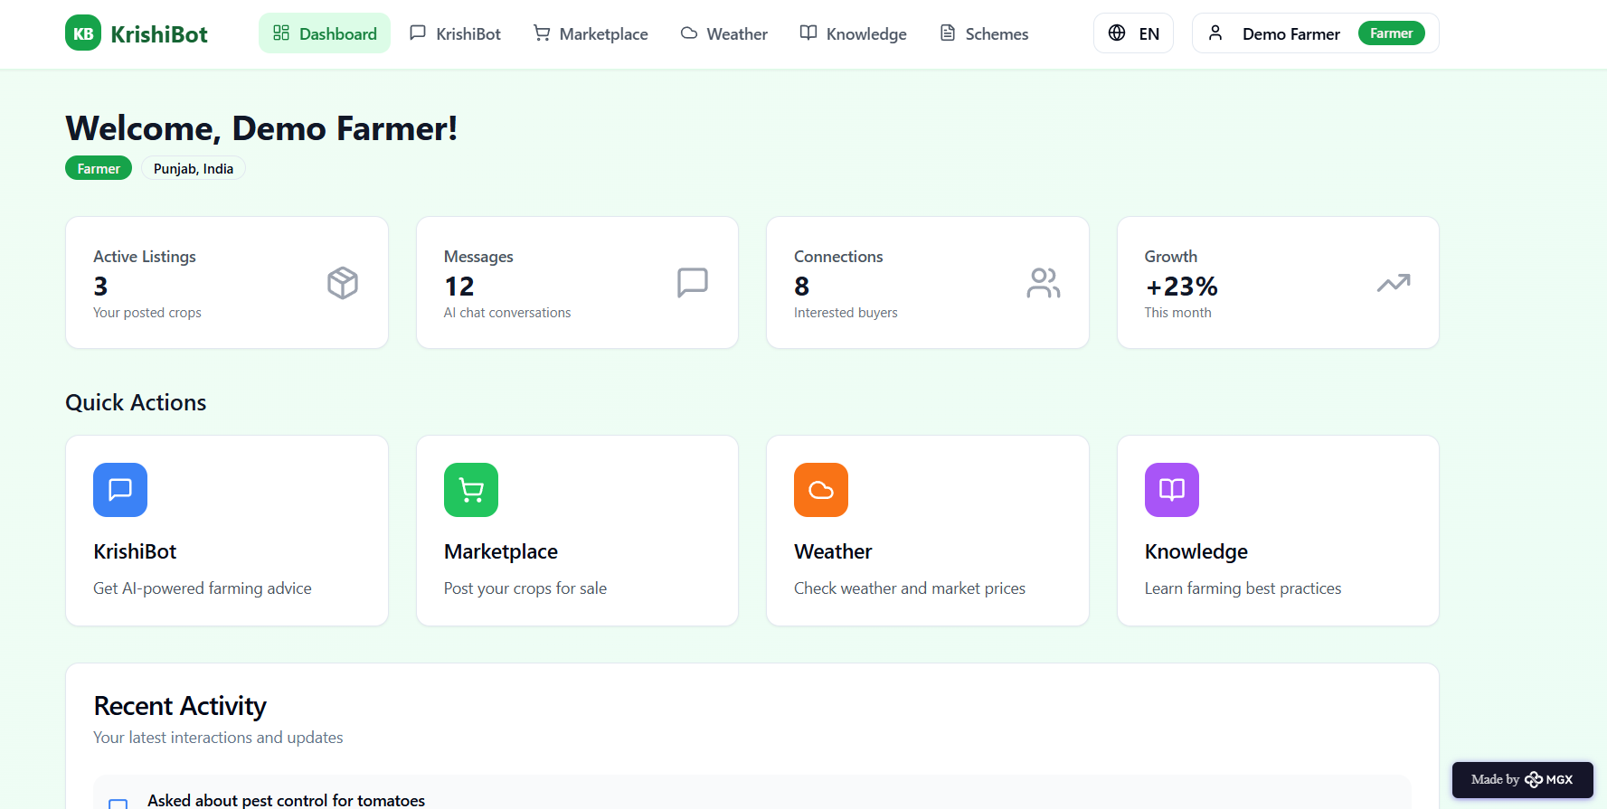

Internal Working of tool:

Profile Creation:

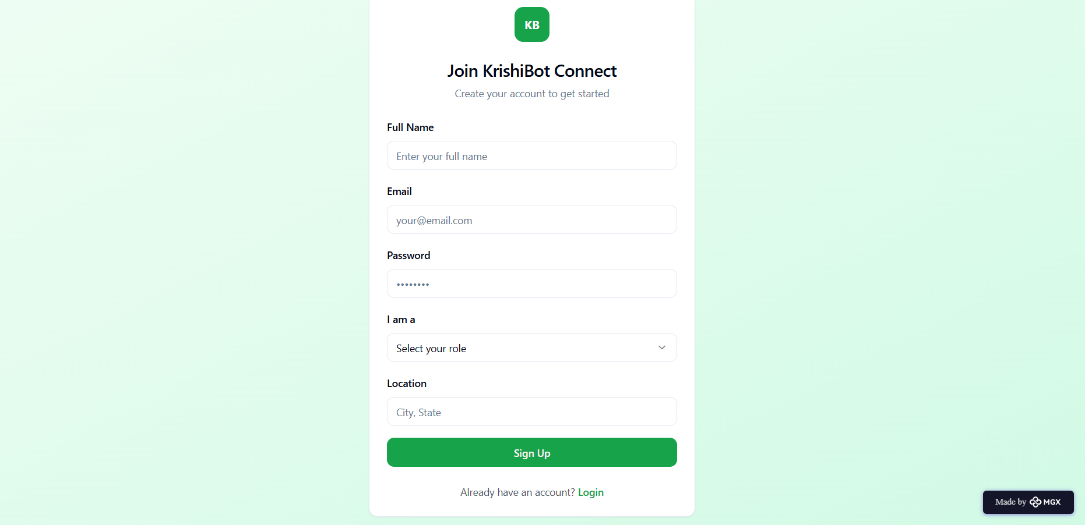

Virtual Assistant–Based User Recommendation Feature

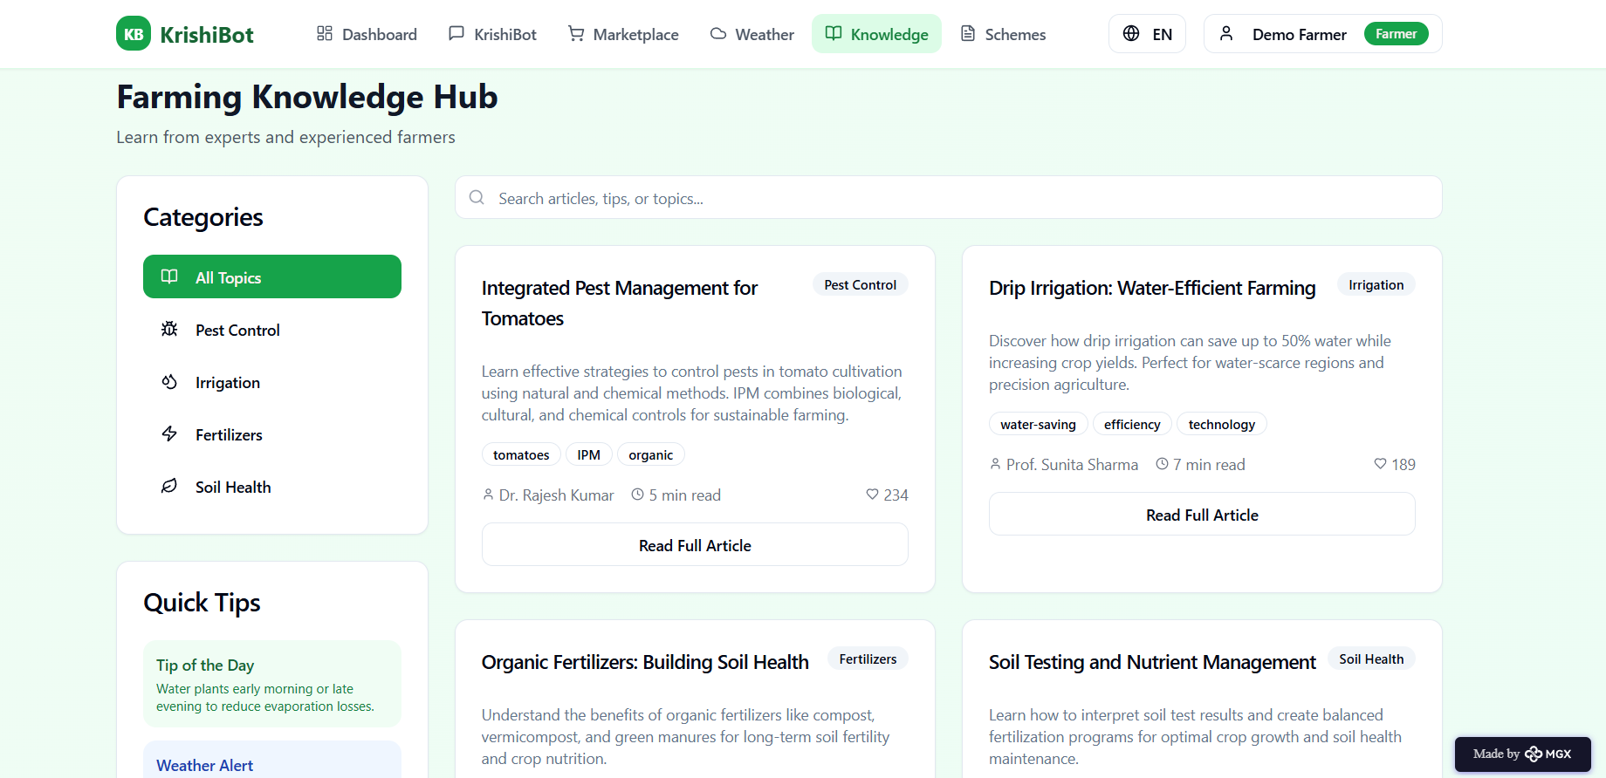

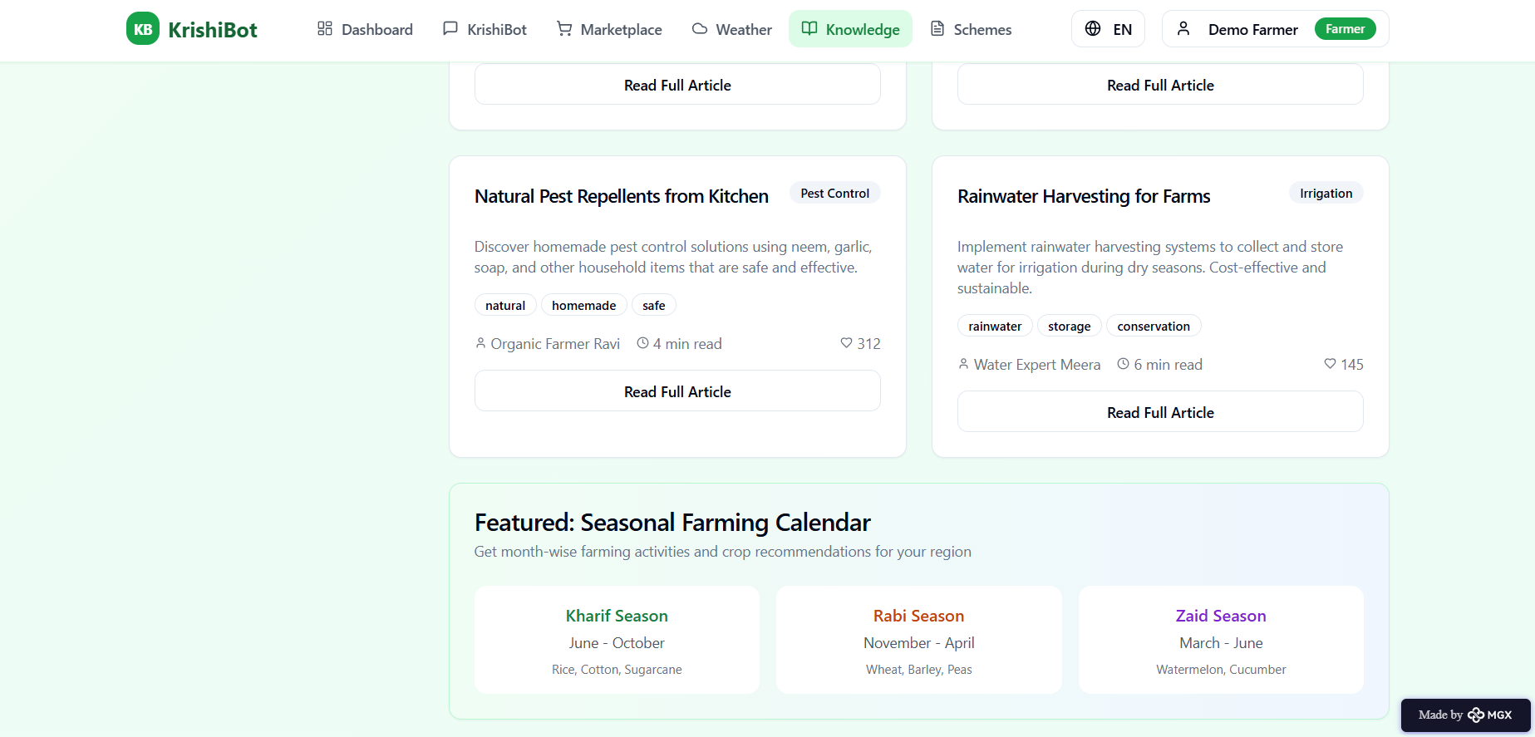

Market place in the application:

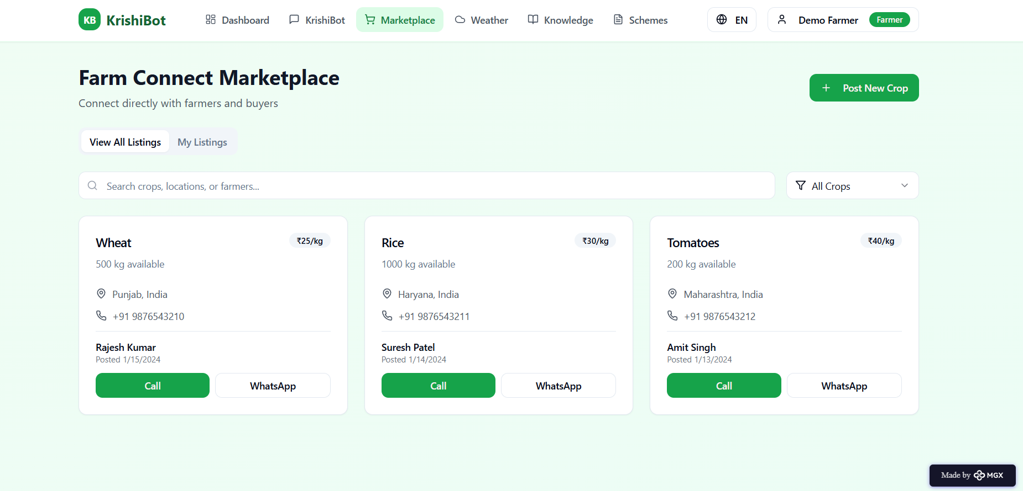

Schemes Recommendations based on Profile:

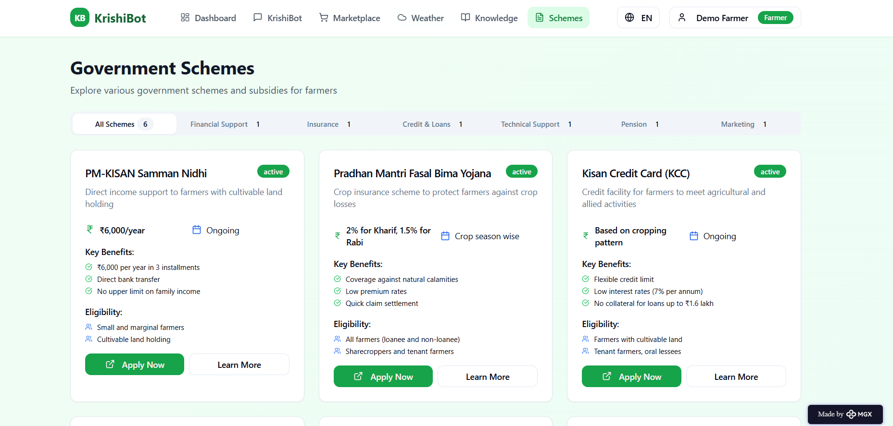

*Step 7: Test – Getting Feedback*

* Who did I share my solution with?

I shared my **KrishiBot Connect** solution with:

* **Farmers from rural areas –** to get feedback on usability, language support, and accuracy of farming advice.
* **Agriculture officers and local experts –** to understand how effectively it provides crop and scheme information.
* **Buyers and traders –** to evaluate the marketplace feature and ease of connecting with farmers.
* **Peers and mentors** – for suggestions on improving design, AI chatbot flow, and user interaction.

What feedback did I receive?

**Feedback: Pros and Cons**

**Pros (Positive Insights from Feedback):**

1. Farmers found the **AI assistant** very helpful for quick advice on crops, fertilizers, and pest control.
2. The **multilingual support (English, Hindi, Kannada)** made the chatbot easy to use for rural users.
3. Users appreciated the **marketplace feature**, which connects farmers directly with buyers without middlemen.

**Cons (Areas to Improve Noted in Feedback):**

1. The chatbot sometimes gives **repetitive or delayed responses** during continuous use.
2. Certain features like **weather and market APIs** need faster data loading and caching.
3. The prototype has **limited offline access**, which affects usability in low-network rural areas.

**My Response for The Feedback:**

**KrishiBot Connect** is a solution developed using full-stack MERN technology and AI APIs. Since this is the initial prototype, some integrations—like real-time market data, voice translation, and offline features—are limited. To achieve full functionality, collaborations with **agriculture departments, weather data providers, and local marketplaces** will be needed. These limitations arise from the prototype stage, but the concept clearly demonstrates the **potential, usability, and real-world impact** of KrishiBot Connect in empowering farmers and creating a digital ecosystem for smart agriculture.

👍 What works well:

**What Works Well**

* **Accessible Anytime:** KrishiBot Connect is a web-based platform that farmers and buyers can access anytime without the need for app installation or subscription.
* **Full-Stack Development:** Built using the MERN stack, it allows smooth integration of AI, database, and real-time APIs for weather, markets, and multilingual chat.
* **Personalized Farming Guidance:** The AI assistant offers tailored advice on crops, fertilizers, pest control, and government schemes based on user input.
* **Farmer–Buyer Connectivity:** The integrated marketplace directly connects farmers with verified buyers, promoting fair trade and transparency.
* **Location-Based Insights:** Farmers can view weather updates, market prices, and nearby buyers based on their location, helping them make informed decisions.
* **Mobile-Friendly and Intuitive:** The platform is responsive and easy to navigate, ensuring smooth access for users even in rural areas with low-end devices.

🔧 What needs improvement:

* **Chatbot Responses:** The AI occasionally repeats or delays answers, so improving response accuracy and contextual understanding is necessary.
* **Interactive Features:** Some modules like the weather and market dashboards need better real-time integration and faster data refresh.
* **Data Integration:** Currently limited to a few APIs; adding more agricultural and government databases would enhance reliability.
* **Collaborations Needed:** Partnerships with agriculture departments, NGOs, and local marketplaces are essential to expand real-world functionality.
* **User Experience Enhancements:** UI can be made more visually engaging and voice-interactive for better accessibility in rural regions.

*AI Tools you can use for Step 6-7:*

**ChatGPT/Perplexity AI/Claude AI/Canva AI/Chatling AI/Figma AI/Metamgx/Gamma AI**: You can use these tools to build solutions/models or mock-up dummy prototypes.

***Day 4: Showcase***

*Step 8: Presenting my Innovation:*

I am presenting **KrishiBot Connect**, a full-stack MERN web application designed to empower farmers and buyers through AI-driven agricultural solutions. It features:

* An **AI-powered multilingual farming assistant** that provides personalized guidance on crop cultivation, fertilizers, pest control, weather, and government schemes.
* A **Farm Connect Marketplace** where farmers can post their crops for sale and buyers can directly contact them, ensuring fair and transparent transactions.
* A **Weather and Market Dashboard** displaying real-time updates on temperature, rainfall, and crop market prices using trusted APIs.

**Impact:** KrishiBot Connect helps farmers make **data-driven farming decisions**, promotes **direct farmer–buyer connections**, and increases **awareness of government schemes and sustainable practices**. It bridges the technological gap in agriculture, improving efficiency, income, and overall rural development.

**<SHOWCASE YOUR INNOVATION TO YOUR PEERS>**

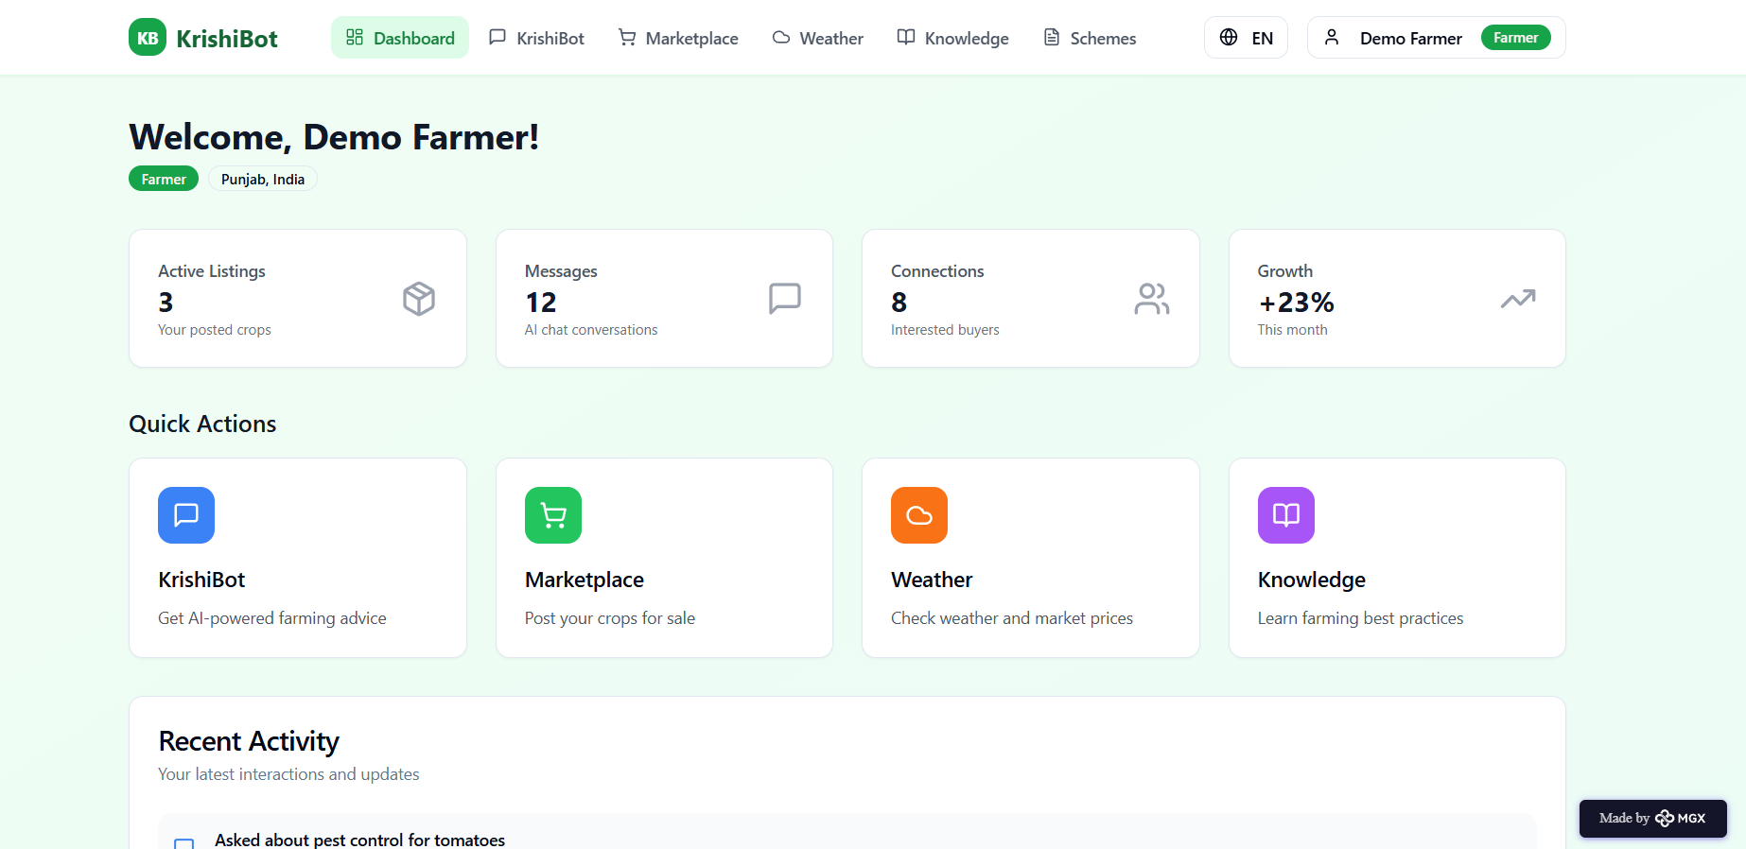

*Step 9: Reflections*

* What did I enjoy the most during this project-based learning activity?

I enjoyed developing **KrishiBot Connect** using the full-stack MERN framework and integrating AI features to bring my idea to life. It was exciting to design the **AI farming assistant**, create the **farmer–buyer marketplace**, and see how multilingual communication could empower farmers to make smarter and more confident agricultural decisions.

What was my biggest challenge during this project-based learning activity?

My biggest challenge was **integrating multiple features**—such as the AI farming assistant, weather and market APIs, and the farmer–buyer marketplace—smoothly within the MERN framework. Ensuring accurate **multilingual responses**, secure **authentication**, and stable **real-time data integration** with limited resources required careful debugging and testing throughout the development process.

**Take-home task**

[**https://github.com/RAJATH-G/Nocode_KrishiBot-Connect**](https://github.com/RAJATH-G/Nocode_KrishiBot-Connect)

*AI Tools you can use for Step 8:*

**Canva AI:** You can use this tool to **design the project pitch document or presentation** for **KrishiBot Connect**. It helps create visually appealing posters, infographics, and slides showcasing the app’s features, workflow, and impact. Once designed, you can **download the pitch as a PDF** and **upload it to GitHub or your project repository** for sharing and presentation.